**TRIBHUVAN UNIVERSITY**

**INSTITUTE OF ENGINEERING**

Kathmandu Engineering College

Kalimati, Kathmandu

**Minor Project Final Report**

**on:**

**IOT-BASED CAR PARKING SYSTEM**



Submitted By:

Aarati Shrestha (76002)

Reet Aryal (76018)

**DEPARTMENT OF ELECTRONICS, COMMUNICATION**

**&**

**INFORMATION ENGINEERING**

April-2023

**TRIBHUWAN UNIVERSITY**

**INSTITUTE OF ENGINEERING**

Kathmandu Engineering College

Department of Electronics, Communication and Information Engineering

CERTIFICATE

The undersigned certify that they have read and recommended to the Department of Electronics, Communication and Information Engineering, a final year project work entitled “IOT Based Car Parking System” submitted by Aarati Shrestha (76002) and Reet Aryal (76018) in partial fulfillment of requirements for the degree of Bachelor of Engineering.

Er. Ravi Poudel Prof. Kishor Adhikari

(Project Supervisor) Department of Electronics and

Lecturer Computer Engineering Kathmandu Engineering College Institute of Engineering (IOE)

Er. Sujan Shrestha

(Project Coordinator)

Department of Electronics and

Computer engineering

Kathmandu Engineering College

Er. Rajan Lama

(Head of Department)

Department of Electronics and

Computer engineering

Kathmandu Engineering College

**ACKNOWLEDGMENT**

We owe our deepest gratitude to our project supervisor **Er. Ravi Poudel** for giving us the necessary guidance to approach this project and review of this report. We would like to sincerely thank **Er. Sujan Shrestha** sir, Project Coordinator and Supervisorfor his generous and continuous support for helping us in the different aspects of the way of performing this project. We would like to extend our sincere gratitude to **Er. Rajan Lama** sir**,** Head of the Department of Electronics and Communications Engineering for providing us with this opportunity to perform our Major project.

We would also like to send our regards to the faculty members, teachers, and individuals who helped us with their valuable support and suggestions for building up the report.

**ABSTRACT**

In the early times, the concepts of smart cities gained great popularity. Concerning the amount of population, the utilization of personal vehicles also has increased. Due to more use of cars, traffic congestion occurs more often on the road. Most of the people choose personal vehicles rather than public transportation. It is very difficult and time consuming to find parking space in most metropolitan areas, commercial areas, especially during the rush hours. It is often costly in almost every big city in all over the world to find proper and secure parking space.

A Car parking system is the smart parking system that delivers information to people, finding a parking space or vacant areas online. It overcomes unnecessary time consuming for overcoming the problem of parking space in cities. Hence, the website is provided by this project based system where users can view various parking areas and choose the space from available slots. The proposed Smart Parking system consists of an on-site deployment of an IOT module that is used to monitor and signalize the state of availability of parking space.

In this project, we deal with design and development to use car parking system using ARDUINO board, WIFI Module, sensors RFID and many more devices. The IoT-based smart car uses heterogeneous sensors.  With the help of this project, Vehicle owner can connects and check if there is a vacant parking spot exist in a parking lot. Using mobile applications, the system will help the user to detect the parking space in the user’s current area. The Ultrasonic Range Detection Sensor is utilized with Arduino to indicate the empty slot and also open and close the gate. By measuring the distance using ultrasonic sensor drivers can find the empty slot in parking to park the car and help the driver to find the slot easily and reduce the searching time. With the help of RFID reader, Only validated RFID card holder can enter parking area.

**TABLE OF CONTENTS**

ACKNOWLEDGEMENT i

ABSTRACT ii

LIST OF CONTENT iii

LIST OF FIGURES v

LIST OF ABBREVIATION………….………..……………………………………………… vi

CHAPTER 1: INTRODUCTION 1

1.1 Background Theory 1

1.2 Problem statement 1

1.3 Objectives 2

1.4 Applications 2

1.5 Scope of Project 2

1.6 Organization of Report 2

CHAPTER 2: LITERATURE REVIEW 3

CHAPTER 3: RELATED THEORY 5

3.1 ARDUINO UNO 5

3.2 ESP 8266 WIFI Module 6

3.3  Ultrasonic Sensor 7

3.4 RC55 RFID Module and Tags ………………………………………………………...8

3.5 Servo Motor ...9

3.6 Software Descriptions………………………………………………………..................10

CHAPTER 4: METHODOLOGY 12

4.1 Block Diagram 12

4.2 Algorithm 13

4.3 Flow Chart 14

CHAPTER 5: RESULT AND ANALYSIS .15

5.1 Work Completed …………………………………………....………………..15

5.2 Problems Encountered.…...……….…………………………………….…….17

REFERENCES .18

**LIST OF FIGURES**

Figure 3.1: ARDUINO UNO 5

Figure 3.2: ESP 8266 WIFI Module………………………………………………………….6

Figure 3.3: Ultrasonic Sensor………………………………………………………………...7

Figure 3.4: RC55 RFID Module and Tags  ..8

Figure 3.5: Servo Motor ..9

Figure 3.6: Software Components 10

Figure 4.1 Block Diagram 12

Figure 4.3 Flow Chart 14

Figure 5.1.1 Simulation……………………………………………………………………..15

Figure 5.1.2 Parking space Information………….…………………………………………16

Figure 5.1.3 Authority message………………..……………………………………………17

**LIST OF ABBREVIATION**

ESP Encapsulating Security payload

GND Ground

IC Integrated Circuit

IOT Internet of Things

IP Internet Protocol

IR Infrared

I2C Inter-Integrated Circuit

LCD Liquid Crystal Display

LED Light Emitting Diode

LIPO Lithium Polymer

RFID Radio Frequency Identification

SCL Serial Clock Line

SDA Serial Data Line

SOC System on-Chip

TCP Transmission Control Panel

UART Universal Asynchronous Receiver Transmitter

UID Unique Identifiers

WIFI Wireless Fidelity

**CHAPTER 1**

**INTRODUCTION**

* 1. **Background Theory**

An IOT is a system of interrelated computing devices, mechanical and digital machines, objects, animals or people that are provided with [UIDs](https://internetofthingsagenda.techtarget.com/definition/unique-identifier-UID) and the ability to transfer data over a network without requiring human-to-human or human-to-computer interaction. An IOT based parking system is a vehicle parking management system to ease the search for a vacant parking spot in a parking lot through a smartphone. The system utilizes various sensors and microcontrollers with internet capability for detecting parked vehicles and to update the data in real-time on internet. Increasingly, organizations in a variety of industries are using IoT to operate more efficiently, better understand customers to deliver enhanced customer service, improve decision-making and increase the value of the business.

At the point when IOT is increased with sensors and actuators, the innovation turns into an occurrence of the more broad class of digital physical frameworks, which likewise incorporates advances. For Example, keen networks, virtual power plants, brilliant homes, astute transportation and shrewd urban communities. Among the difficulties that confront in everyday life one of most unavoidable test is parking the car wherever people go. As our need expands our setting out increments however because of extreme increment in utilization of vehicles and increment in populace this project confront the intense assignment of parking car especially amid busiest hours of the day. Amid pinnacle hours the majority of the saved parking zone gets full and this leaves the client to scan for their parking among other parking area which makes more movement and abandons them with no sign on accessibility of parking spot. To defeat this issue there is certainly a requirement for composed parking in business condition. To outline such parking there need to assess reservation of parking space with ideal parking spot which relies upon cost and time. However, this project composes the time driven grouping strategy which takes care of the issue of parking utilizing opening assignment technique.

* 1. **Problem Statement**

Due to the increase in demand of vehicle in the city area, the problem of parking has been increasing drastically especially in city areas. Some of the major problems are:.

* Ineffective management.
* Inadequate car parking space.
* Heavy traffic congestion.

**1.3** **Objectives**

* To develop a user-friendly automatic car parking system.
* To reduce traffic congestion and offer safe and secure parking slots within limited area.
* To minimize the time taken and hassle factor of locating an available parking space at low cost providing maximum automation.
  1. **Applications**
* To optimize parking space usage.
* To improve the efficiency of parking.
* To help smoother traffic flow.
* To upgrade security safety and privacy.
* To prevent unauthorized access to parking lot.
  1. **Scope of Project**
* Increase safety and security.
* Proper management of available space.
  1. **Organization of Report**

Chapter 1: Deals with introduction and objective of this project.

Chapter 2: Literature review and motivation behind this project.

Chapter 3: Basic theory and principle on how the components work.

Chapter 4: Deals with methodologies

Chapter 5: Deals with the obtained output and encountered problem

**CHAPTER 2**

**LITERATURE REVIEW**

The demand of parking space has been increasing on a daily basis all over the world. The numbers of vehicles in use are increasing day by day and there is no provision for parking in such a busy city. We see vehicles parked on a street in much unmanaged ways due to which there is unmanageable traffic jams and also increasing accidents.

Various methods are prevalent for development of autonomous or intelligent parking systems. Study of these systems shows that these require a little or more human intervention for the functioning. One of the early researches in this topic was done in 2007. Researcher worked on integrated approach in the design of car park occupancy information system [1]. In large parking areas such as those at mega shopping malls or stadiums, drivers always have difficulty to find vacant car park lots especially during peak periods or when the parking lots are almost full. A solution to reduce the drivers’ searching time for vacant car-park lots will greatly save time, reduce cost and improve the traffic flow in the car park areas. To enhance the parking management, an intelligent parking system was developed which reduced the purpose of hiring people to maintain the parking system [2].

Another similar type of research which included image processing as well was done [3]. This paper aims to present an intelligent system for parking space detection based on image processing technique that capture and process the brown rounded image drawn at parking lot and produce the information of the empty car parking spaces. It will be display at the display unit that consists of seven segments in real time.

In 2012, Carmated car parking system commanded by android application was proposed and it aimed to carmate the car and car parking as well [4]. A miniature model of a carmated car parking system that can regulate and manage number of cars that can be parked in given space at any given time based on the availability of parking slot. Carmated parking is a method of parking and existing cars using sensing device.

Internet of Things (IOT) plays a vital role in connecting the surrounding environmental things to the network and made easy to access those un-internet things from any remote location [5]. It’s inevitable for the people to update with user to find the nearest parking area and gives availability of parking slots in that respective parking area. And it mainly focus on reducing the time in finding the parking lots and also it avoids the unnecessary travelling through filled parking lots in a parking area. And it mainly focus on reducing the time in finding

the parking lots and also it avoids the unnecessary travelling through filled parking lots in a parking area. Thus it reduces the fuel consumption which in turn reduces carbon footprints in an atmosphere. In this study the authors suggested a combination of convolutional neural networks and machine learning techniques that can be applied on the parking systems to make it further more innovative and smart [6]. They present an IOT based smart parking system integrated with cloud [7]. This system is the deployment of an IOT module to present the state of every parking spot available in a particular space and an application allowing the users to view the information and book a spot as per their needs.

Here, In this project we are going to construct a smart vehicle parking system that connects to internet to help a car driver or any vehicle owner to check if there is a vacant parking spot exist in a parking lot even before the driver reach the intended parking lot destination. Also we have taken an initiative by including RFID card. With the use of RFID only designated vehicle or those vehicles which have verified RFID card can enter the parking area which makes it a safe and managed parking place. There will be no illegal entrance of cars.

There are several ultrasonic sensors for detecting cars/vehicles in the parking spot, we are using ultrasonic sensors instead of IR-based sensors because if the parking lot is situated outdoors, infrared light from sunlight may interfere with IR sensors and may give incorrect detection of the vehicle, whereas ultrasonic sensor acts like a mini radar and environmental factors affecting its functionality is minimal. A visible-based car parking system is developed which uses two types of images (positive and negative) to detect free parking slot [8]. In this method, the object classifier detects the required object within the input. Positive images contain images of cars from various angles. Negative images do not contain any cars in them. The coordinates of the parking lots specified are used as input to detect the presence of cars in the region. Haar-like features are used for feature detection. However, limitations may occur with this system concerning the type of camera used. Also, the coordinate system used selects specific parking locations and thus camera has to be at a fixed location. The limited set of positive and negative images may impose limitations on the system.

Thus, we aim to propose a car parking system that represents a fully automated model with minimum human intervention and overcomes the limitations of existing systems.

**CHAPTER 3**

**RELATED THEORY**

In any system, Hardware and Software are the most essential components for the Processing and Implementation of the data. Likewise, the different types of hardware that we used in our project are mentioned below:

1. **Arduino UNO**

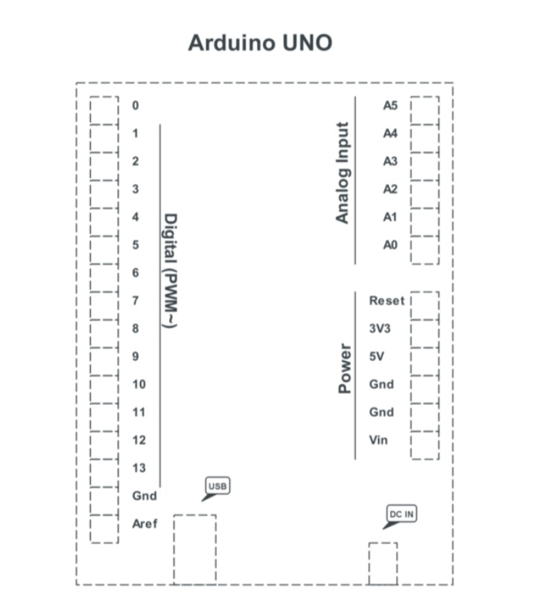

Figure 3.2: Arduino UNO

Arduino UNO. (2013). Retrieved from <https://www.etechnophiles.com/arduino-uno-pinout-pin-diagram-specifications/>

The Arduino Uno R3 is a microcontroller board based on the ATmega328 AVR microcontroller developed by Arduino.cc.The board is equipped with the set of digital and analog pins that can be interfaced to various board and other circuits.It has 14 digital I/O pins (of which 6 can be used as PWM outputs and 6 can be used as analog inputs), an external power supply (9v), Reset button, USB connection, power LED, ICSP header. Programs can be loaded on to it from the easy-to-use Arduino computer program. The versatility of the **pinout** provides many different options such as driving motors, LEDs, reading sensors and more. . "Uno" means one in Italian and was chosen to mark the release of Arduino Software (IDE) 1.0. The Uno board and version 1.0 of Arduino Software (IDE) were the reference versions of Arduino, now evolved to newer releases. The Uno board is the first in a series of USB Arduino boards, and the reference model for the Arduino platform; for an extensive list of current, past or outdated boards see the Arduino index of boards.  It contains everything needed to support the microcontroller; simply connect it to a computer with a USB cable or power it with AC-to-DC adapter or battery to get started.

1. **ESP 8266 Wifi Module**

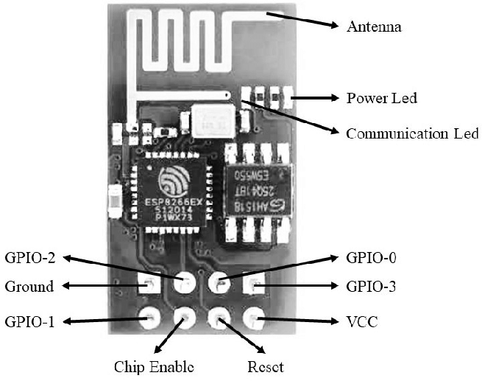

Figure 3.3: ESP8266 Wifi Module

mod. (2014). Retrieved from mod: <https://www.researchgate.net/figure/Configuration-of-ESP8266-WiFi-Module-The-ESP8266>

The ESP8266 Wifi module is a self-contained system-on-chip (SOC) with integrated TCP/IP protocol stacks that can give any microcontroller access to a Wifi network. The ESP8266 is capable of either hosting an application or offloading all Wifi networking functions to another application processes. The ESP8266 is actually a miniature microcontroller board and just like Arduino the ESP8266 need a program code to perform its intended function. It uses UART protocol to communicate with Arduino board; the baud rate we are going to set for UART is 115200 bits per second. Further specification;

Type 32 Bit microcontroller

Memory 32 KiB instruction, 80KiB

This module has a powerful enough on-board processing and storage capability that allows it to be integrated with the sensors and other application specific devices through its GPIOs with minimal development up-front and minimal loading during runtime. Its high degree of on-chip integration allows for minimal external circuitry, including the front-end module, is designed to occupy minimal PCB area.

1. **Ultrasonic Sensor**

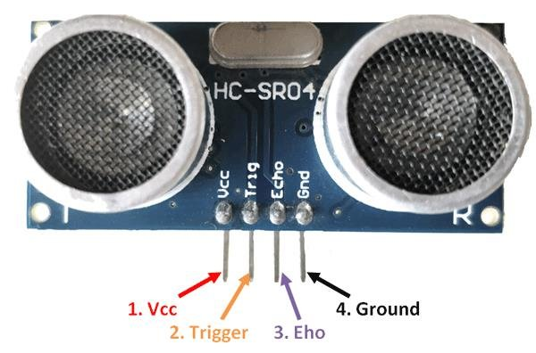

Figure 3.4: Ultrasonic sensor

uss. (2016). Retrieved from uss: <https://components101.com/sensors/ultrasonic-sensor-working-pinout-datasheet>

An ultrasonic sensor is an electronic device that measures the distance of a target object by emitting ultrasonic sound waves, and converts the reflected sound into an electrical signal. Ultrasonic waves travel faster than the speed of audible sound (i.e. the sound that humans can hear). It has two main components: the transmitter (which emits the sound using piezoelectric crystals) and the receiver (which encounters the sound after it has travelled to and from the target). There are 4 pins they are VCC, Echo (signal input pin), Trig (signal output pin) and GND. Each of the four pins are connected to the Arduino: VCC to 5V, Trig and Echo to a digital pin and GND to ground. Basically, we used Ultrasonic sensors because they are cost effective solution for detecting, counting and identifying objects as they can be used in environment with high level of dusts and also can be operated in the presence of sunlight which is not possible in IR since IRs are light sensitive. In order to calculate the distance between the sensor and the object, the sensor measures the time it takes between the emissions of the sound by the transmitter to its contact with the receiver. The formula for this calculation is [D = ½ T x C](https://www.arrow.com/en/research-and-events/articles/ultrasonic-sensors-how-they-work-and-how-to-use-them-with-arduino) (where D is the distance, T is the time, and C is the speed of sound ~ 343 meters/second).  [In comparison to infrared (IR) sensors](https://www.maxbotix.com/articles/ultrasonic-or-infrared-sensors.htm) in proximity sensing applications, ultrasonic sensors are not as susceptible to interference of smoke, gas, and other airborne particles (though the physical components are still affected by variables such as heat).

1. **RC55 RFID Module and Tags**

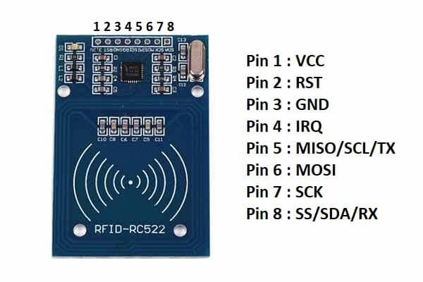 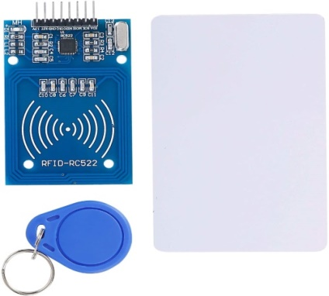

Figure 3.6: RFID module with Tags

rfid. (n.d.). Retrieved from <https://www.amazon.com/SunFounder-Mifare-Reader-Arduino-Raspberry/dp/B07KGBJ9VG>

RFID refers to a wireless system comprised of two components: tags and reader. A Reader is a device that has one or more antennas that emit radio waves and receive signals back from the RFID tag. There are Passive RFID tags and Active RFID tags where the passive tags are powered by the reader mean it does not contain a battery. Instead it contains a microchip that stores and processes information and an antenna to receive and transmit a signal. Active tags can transfer signal as it contains battery. Active tags can be used on very large object however such as wagon or project that have to be controlled in large space. RFID tags can store a range of information from one serial number to several pages of data’s. The RC522 RFID Reader module is designed to create a 13.56MHz electromagnetic field that it uses to communicate with the RFID tags (ISO 14443A standard tags).It is low power, low cost, pretty rugged, easy to interface with and insanely popular among hobbyists. RC522 RFID specifications and Features;

|  |  |
| --- | --- |
| Frequency Range | 13.56 MHz ISM Band |
| Host Interface | SPI / I2C / UART |
| Operating Supply Voltage | 2.5 V to 3.3 V |
| Max. Operating Current | 13-26mA |
| Read Range | 5 cm |

1. **Servo Motor**

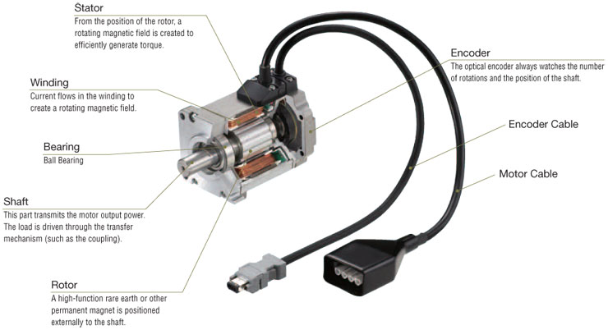

Figure 3.7: Servo Motor

Servomotor (2020) Retrieved from; https://www.electrical4u.com/ servo-motor/

A **servo motor** is a type of electrical device that can rotate and push parts with great precision. It is made up of a simple motor which runs through a **servo mechanism**. If motor is powered by a DC power supply then it is called DC servo motor, and if it is AC-powered motor then it is called AC servo motor. It consists of the three parts i.e Controlled device, Output sensor and Feedback system. Different types of other parts i.e stator, rotor, winding etc are mentioned in the above figure. Here, SG90 motor is used which is a tiny and lightweight server motor with high output power. Servo can rotate approximately 180 degrees (90 in each direction), and works just like the standard kinds but smaller. Furthermore, other specification of servomotor;

* Weight: 9 g
* Dimension: 22.2 x 11.8 x 31 mm approx.
* Operating speed: 0.1 s/60 degree
* Operating voltage: 4.8 V (~5V)
* Temperature range: 0 ºC – 55 ºC

1. **Software Descriptions**
2. **C++ program**

C++ is a statically typed, compiled, case-sensitive, general purpose object oriented programming (OOP) language that is widely used nowadays for competitive programming and for creating large-scale applications. It can be used to develop operating systems, browsers, games and soon. It was created by Danish computer scientist Bjarne Stroustrup starting in 1979 at Bell labs, New York. It has expanded significantly over a time and C++ now has imperative, object-oriented and generic-programming features in addition to facility for low level memory manipulation. In 1982, Stroustrup renamed it as a “C++”. Different new features were added, including virtual functions, function name and operator overloading, references, constants, type-safe free-store memory allocation ( new/delete), improved type checking, and BCPL style single-line comments with two forward slashes(//). This makes C++ more powerful as well as flexible. C++ is being highly used to write device drivers and other software that rely on direct manipulation of hardware under real-time constraints. Furthermore, Stroustrup developed a new standalone compiler for C++, Cfront. It fully supports OOP including its four most significant features i.e. Encapsulation, Data hiding, Inheritance and Polymorphism. Standard C++ consists of three important parts-

* The core language giving all the building blocks including variables, data types and literals, etc.
* The C++ Standard Library giving a rich set of functions manipulating files, strings, etc.
* The Standard Template Library (STL) giving a rich set of methods manipulating data structures, etc.

It supports a variety of programming styles. We can write in the style of FORTRAN, C, Smalltalk, etc. in any language. C++ runs a lot of platforms like Windows, Linux, UNIX, Mac etc.

1. **Tinkercad**

Tinkercad is the free website for 3D modeling design and coding. It was founded by former Google engineer Kai Backman and his co-founder Mikko Monomen. In 2011, the tinkercad.com website was launched as a web-based 3D modeling tool since it became available, it has become a popular platform for creating different 3D models. Tinkercad is an amazingly powerful easy-to-use tool for creating digital designs that are ready to be 3D printed into super-cool physical objects. You will be guided through the 3D design process via easy hands-on "Lessons”, that teach you the basics of Tinkercad before moving on to more complex modeling techniques. Even if it was first established with the intention of constructing 3D models only, now we can also make circuit designs in it. It is an excellent tool that allows you to simulate Arduino-based systems (and a lot more). You can simulate all exercises and even your own designs before trying them on real hardware. It also allows you to do programming using blocks. The beginners can choose among four main categories: Basic, Arduino, Microbit and Circuit assemblies. Codes are written in C++ language in this platform. In present time it also supports MakeCode version of Python. One of the aspects that make Tinkercad so successful is that you only need an internet connection to use it. The main benefits of [TinkerCAD](https://www.tinkercad.com/) are low production costs, quick product completion, and user-friendly interface. Since it is free software, there is no need for subscriptions. It also enables you to customize existing presets to create a unique design for your product.

1. **HTML**

HTML stands for Hypertext Markup Language. It is basically used for creating web pages and web applications. The history of HTML is closely tied to the development of the World Wide Web. It was first introduced in 1990 by Tim Berners-Lee, a computer scientist at CERN, as a way to share information among researchers. Since then it has become the standard markup language for the web. It uses tags to define the structure and content of a web page. Tags are surrounded by angle brackets (< >) and can have attributes that provide additional information about the content. The most basic element is the <html> tag which contains the entire document. The structure of an HTML document includes a head section, which contains Meta information about the page, and a body section, which contains the main content of the page. It provides a wide range of attributes that can be used to modify the behavior or appearance of elements such as ‘href’ attribute for links, the ‘src’ attributes for images and the ‘class’ attribute for styling with CSS. HTML also allows for the creation of semantic markup which provides additional meaning and context to the content of a web page. This can be helpful for search engine optimization and accessibility. There are various version of HTML. Among them HTML5 is the latest version of HTML which was released in 2014 and includes new features and improvement such as support for multimedia elements, new form controls and more.

In simple word, HTML is a markup language not a programming language which can be used to structure and present content on a web page but it cannot perform complex calculations or logic. It can be combined with other web technologies such as CSS (Cascading Style Sheets) and JavaScript to create interactive and dynamic web pages that can be accessed from a variety of devices and platforms.

Today, HTML is a fundamental technology that underlies most of the web. It is an essential skill for anyone who wants to create web pages, and it continues to evolve as new web technologies are developed.

**CHAPTER 4**

**METHODOLOGY**

**4.1** **BLOCK DIAGRAM**

Servomotor

Sensors

Buzzer

Arduino Uno

Wi-Fi Module

LED

Cloud

RFID

Supply

Figure 4.1: Block Diagram

**4.2** **Algorithm**

Step 1: Start

Start 2: Microcontroller receives signal from rfid reader

Step 3: Microcontroller program sends trigger pulse to the buzzer, led and servomotor

Step 4: Wifi module transmits trigger pulse to the server

Step 5: Web Browser gets data from cloud about free parking slots.

Step 6: If vacant slots then,

Display vacant spaces

Otherwise;

Display no space

Step 7: Scan RFID card

Step 8: Check if it is authorized

Buzzer buzzes and Green LED glows

Otherwise;

Red LED glows

Step 9: Enter parking space

Step 10: Stop

**4.3** **Flow chart**

Start

Controller receives pulse

Controller transmits signal to servomotor and others

Parking information is sent to cloud

Sends slot information to Browser

Sends slots information to Browser

Sends slots information to Browser

YES NO

Any slots?

Scan RFID card

Display no space

NO

Authorized?

YES

Enter Parking space

Stop

**CHAPTER 5**

**RESULT AND ANALYSIS**

**5.1** **Work Completed**

We have done the simulation portion of IOT Based Car Parking System and have shown basics of how this project runs. For the simulation process, we used TinkerCAD which is an online platform. We used various components for the simulation process as shown in the figure below.

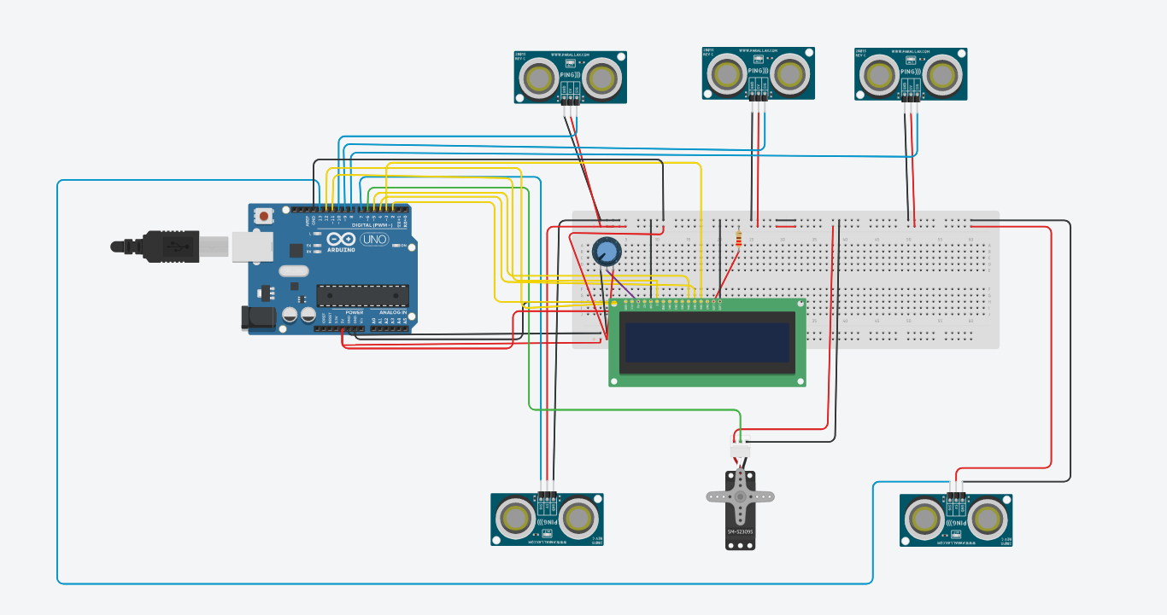

Fig 5.1.1: Simulation of IOT based Car Parking System

Here, potentiometer is added because potentiometer is an input device of Arduino that can be used for various purposes like controlling the brightness of LED or LCD by increasing or decreasing its resistance.

As shown in the figure above, we did the simulation part of our project. The components used are Arduino UNO, LCD, ultrasonic sensors, servo motor, and resistor embedded on breadboard. The two ultrasonic sensors located in the bottom lies on gate. The upper three sensors are for parking slots. When the car enters, first it passes through bottom left sensor which rotates the servo motor i.e. the entrance door opens and after it passes bottom right sensor, the servo motor rotates again which means, the door closes. Now, it has three places to park the vehicle. Suppose we park at a slot, the message according to it will be displayed on LCD. Similar process will occur when the car has to come out of the parking area. The simulation portion of our project has been completed and it has been functioning as per our expectations.

For the hardware portion, we interfaced Arduino with RFID, servo motor, LED and buzzer. When the driver scans rfid card in the reader, they can enter if the card is authorized otherwise they cannot enter the parking space. Once the card is verified, the buzzer indicate it’s approval and the white led turns on and the servomotor allows the blockage to open. If the card is not validated then red led turns on and the driver cannot enter the parking area.

In our project, we used NodeMcu8266 module to transfer information related to parking areas to the users. We interface NodeMcu Wifi-module with the Ultra-sonic sensor with the help of which module can transfer information or the parking details to the Server through cloud. We created browser using HTML code and interfaced it with Nodemcu. In every sec, Browser gets updated and shows real time data. To get the information regarding the availability of parking areas, Users have to search in searching bar of web browser with the provided IP- Address and they can easily get information about the vacant and occupied slot areas.

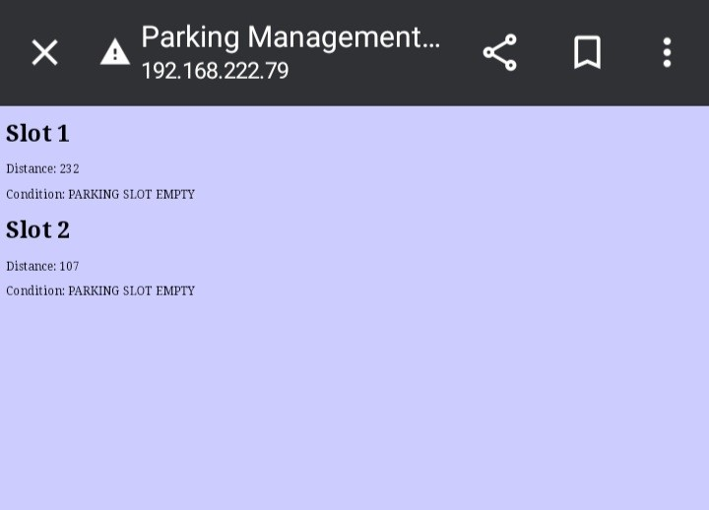

Fig 5.1.2 Parking space Information

This is how it shows when user login browser using provided validated IP-address.

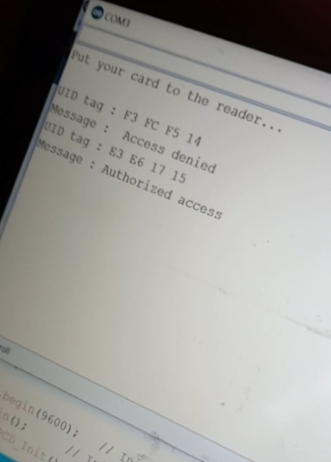

Fig 5.1.3 Authority message

Case1: When RFID is not accessible.

Case 2: When RFID is accessible.

**5.1** **Problems Encountered**

During this project, we encountered some problems, not major ones but some of the works were not up to what we expected. Interfacing for LCD display was not possible because the module did not show any response when connected to either arduino or node MCU.

**REFERENCES**

1. D.B.L. Bong, K.C. Ting and K.C. Lai “Integrated approach in the design of car park occupancy”. In: IEEE International conference on Electrical, Electronics and communication and information. March 7-8, 2007.
2. Thanh Nam Pham1, Ming-Fong Tsai1, Duc Bing Nguyen1, Chyi-Ren Dow1 and Der-Jiunn Deng2. “A cloud based smart Parking System Based on Internet of Things Technologies”. IEEE Access, volume3. Pp. 1581-1591. September 2015.
3. R. Yusnita, Fariza Norbaya, and Norazwinawati Basharuddin,“Intelligent Parking Space Detection System Based on Image Processing”. In: International Journal of Innovation, Management and Technology. June 2012
4. D.J. Bonde, rohit S. Shende, Akshay S. Kedri, Amol U. Bhokre. “Automatic Car Parking System Commanded by Android Application”. In: International Journal of Computer Science and Information technologies (IJCSIT). 2012
5. Mr. Basavaraju S R, “An Carmated Car parking system Using Internet of Things (IOT)”. In: International Journal of Computer Applications, July 2017.
6. Paidi, Vijay & Fleyeh, Hasan & Håkansson, Johan & Nyberg, Roger. “Smart parking sensors, technologies and applications for open parking areas”. 2018.
7. A. Khanna and R. Anand. "IOT Based Smart Parking System". In: International Conference on Internet of Things and Applications (IOTA), Pune. 2016.
8. Hamada R.H. ,Patrick Sebastian, Daniel Devaraj, Yap Vooi ,“Vision-based automated parking system.” Information Science, Signal Processing and their Applications (ISSPA 2010), pages 757-760. 2010.
9. “Components” [Online] Available <https://www.researchgate.net/figure/List-of-Components-that-been-used-for-smart-car-park-system_tbl1>